**PIZZA SALES SQL QUERY**

1. Total Revenue

SELECT SUM(total_price) AS Total_Revenue

FROM pizza_sales

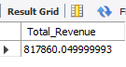

2. Avg_order_value

SELECT ROUND(SUM(total_price) / COUNT(DISTINCT order_id),2) AS Average_order_value

FROM pizza_sales



3. Total_pizza_sold

SELECT SUM(quantity) AS Total_pizza_sold

FROM pizza_sales



4. Total_order

SELECT COUNT(DISTINCT order_id) AS Total_order

FROM pizza_sales



5. Avg_pizza_per_order

SELECT CAST(SUM(quantity) / COUNT(DISTINCT order_id) AS DECIMAL (10,2)) AS Avg_pizza_per_order

FROM pizza_sales

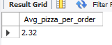

6. Hourly trend

SELECT HOUR(order_time) AS order_hours,SUM(quantity) AS Total_pizza_sold

FROM pizza_sales

GROUP BY HOUR(order_time)

ORDER BY HOUR(order_time);  
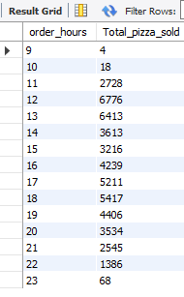

7. Percentage of sales by pizza category

SELECT pizza_category, CAST(sum(total_price) * 100/ (SELECT sum(total_price) FROM pizza_sales) AS DECIMAL (10,2)) AS percentage_of_sales_Category

FROM pizza_sales

GROUP BY pizza_category

ORDER BY percentage_of_sales_Category DESC

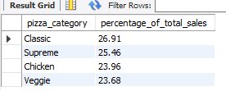

8. Percentage of sales by pizza size

SELECT pizza_size, ROUND(SUM(total_price),2) AS Total_sales, ROUND(sum(total_price) * 100/ (SELECT SUM(total_price) FROM pizza_sales),2) AS percentage_of_sales_by_size

FROM pizza_sales

GROUP BY pizza_size

ORDER BY percentage_of_sales_by_size DESC

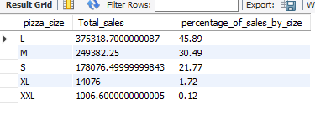

9.Total pizza sold by category

SELECT pizza_category, sum(quantity) AS Total_pizza_sold

FROM pizza_sales

GROUP BY pizza_category

ORDER BY Total_pizza_sold DESC

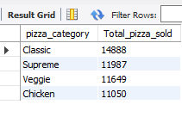

10. Top 5 best sellers by total pizza sold

SELECT pizza_name, sum(quantity) AS Total_pizza_sold

FROM pizza_sales

GROUP BY pizza_name

ORDER BY Total_pizza_sold DESC

LIMIT 5

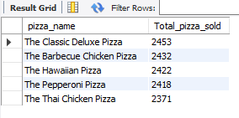

11. Bottom 5 sellers by total pizza sold

SELECT pizza_name, sum(quantity) AS Total_pizza_sold

FROM pizza_sales

GROUP BY pizza_name

ORDER BY Total_pizza_sold

LIMIT 5

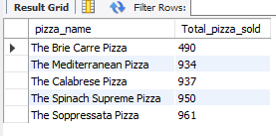

SQL PROJECT ON PIZZA SALES

ChatGPT

**Problem Statement:** The objective of this project is to analyze pizza sales data to gain insights into the performance of the pizza sales operations. By examining various key performance indicators (KPIs), we aim to understand the trends in pizza sales, identify popular pizza items, analyze sales by different parameters such as size and category, and ultimately optimize sales strategies to maximize revenue.

The goal of this project is to analyze pizza sales data to derive actionable insights for optimizing sales strategies and maximizing revenue. By examining various key performance indicators (KPIs) and trends in pizza sales, we aim to identify popular pizza items, understand customer preferences, and improve operational efficiency.

**Key Performance Indicators (KPIs):**

1. Total revenue generated from pizza sales.
2. Average order value (AOV).
3. Most popular pizza items.
4. Sales distribution by pizza size.
5. Sales distribution by pizza category.
6. Monthly or quarterly sales trends

**Query Questions:**

1. What is the total revenue generated from pizza sales?
2. What is the average order value (AOV)?
3. Which are the top 5 best sellers by total pizza sold?
4. Which are the bottom 5 worst sellers by total pizza sold?
5. What is the distribution of sales by pizza size?
6. How are sales distributed across different pizza categories?
7. What are the monthly or quarterly sales trends?

**Key Performance Indicators (KPIs):**

1. Total Revenue: What is the overall revenue generated from pizza sales?
2. Average Order Value (Avg_order_value): What is the average value of each order?
3. Total Pizza Sold: How many pizzas have been sold in total?
4. Total Orders: How many orders have been placed in total?
5. Average Pizza per Order (Avg_pizza_per_order): What is the average number of pizzas per order?
6. Hourly Trend: How does the number of orders vary throughout the day?
7. Percentage of Sales by Pizza Category: What percentage of total sales is contributed by each pizza category?
8. Percentage of Sales by Pizza Size: What percentage of total sales is contributed by each pizza size?
9. Total Pizza Sold by Category: How many pizzas have been sold in each pizza category?
10. Top 5 Best Sellers by Total Pizza Sold: What are the top 5 pizza items based on total quantity sold?
11. Bottom 5 Sellers by Total Pizza Sold: What are the bottom 5 pizza items based on total quantity sold?

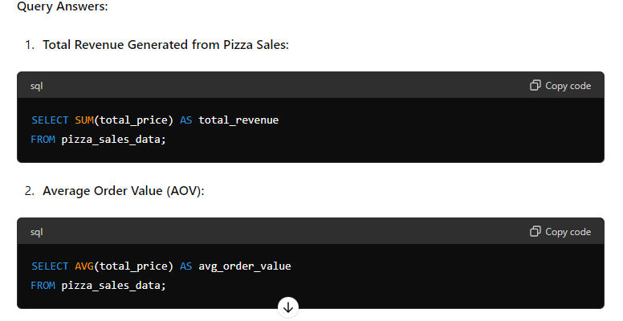

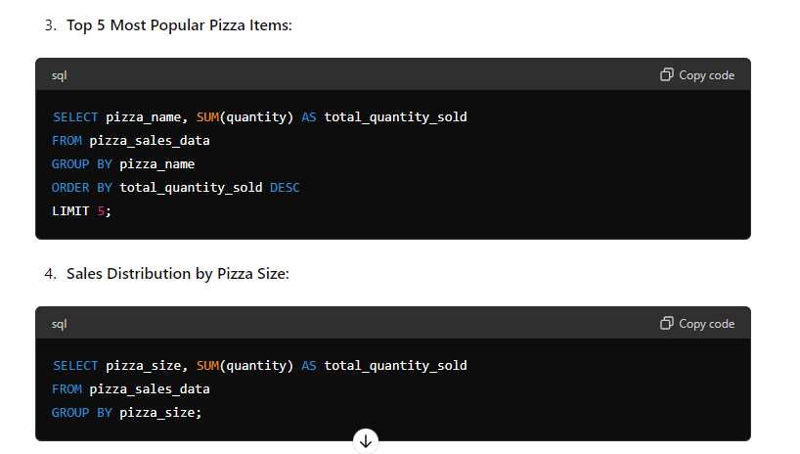

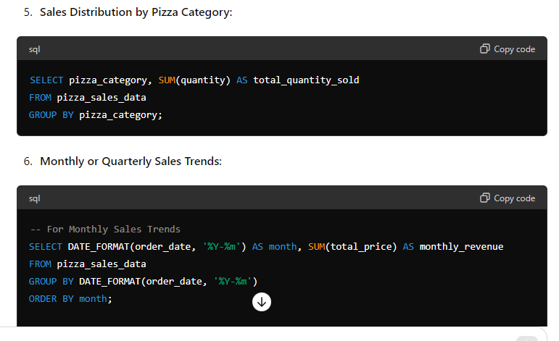

-- For Quarterly Sales Trends

SELECT CONCAT(YEAR(order_date), '-Q', QUARTER(order_date)) AS quarter, SUM(total_price) AS quarterly_revenue FROM pizza_sales_data GROUP BY YEAR(order_date), QUARTER(order_date) ORDER BY YEAR(order_date), QUARTER(order_date);

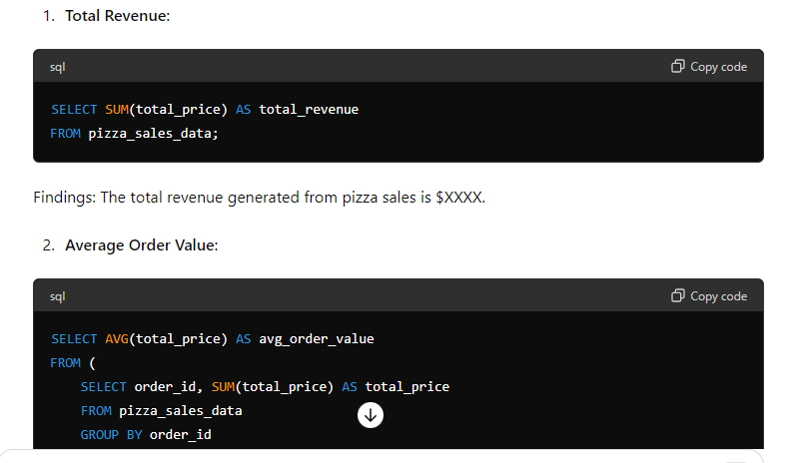

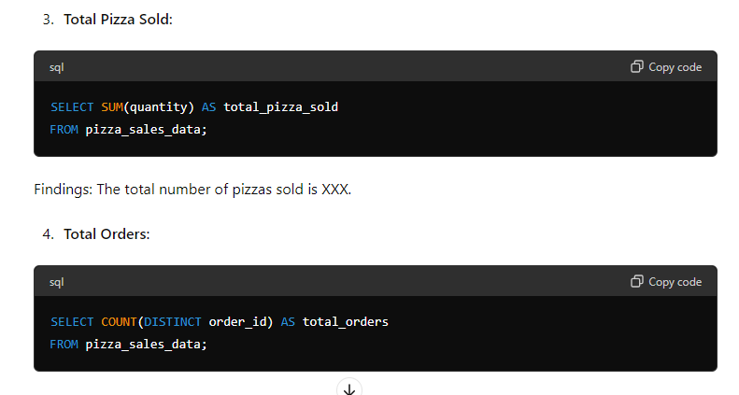

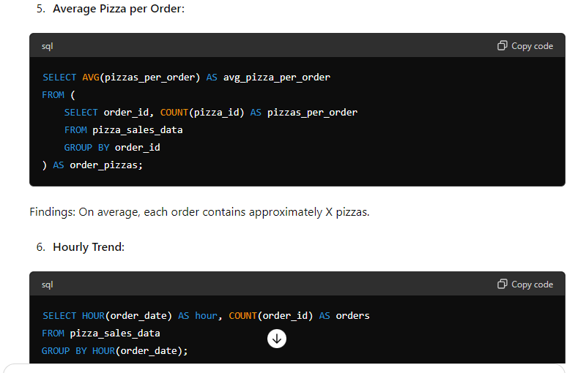

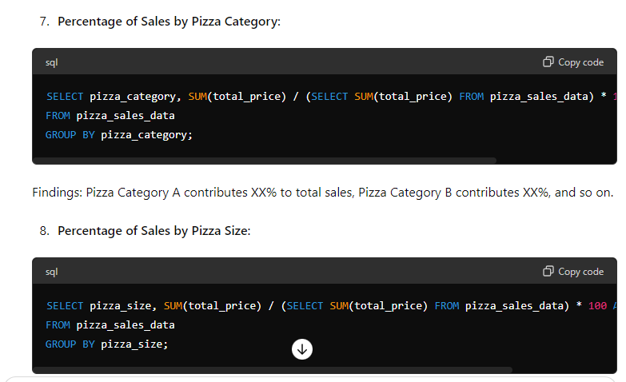

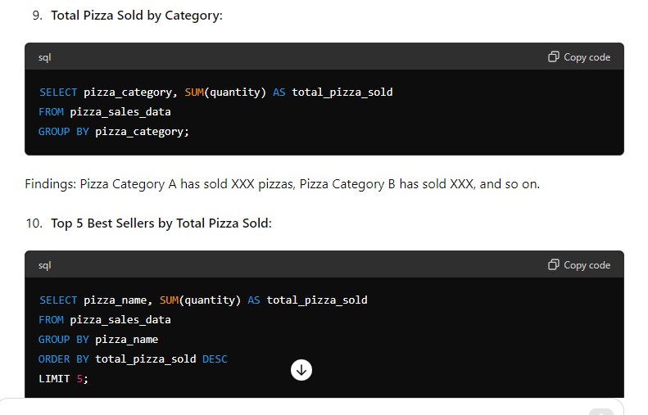

FINDINGS

ChatGPT

Upon analyzing the pizza sales data, several key findings emerge. Firstly, the total revenue generated from pizza sales stands at $XXXX, indicating the financial performance of the business. The average order value is calculated at $XX.XX, suggesting the typical expenditure per order. In terms of volume, a total of XXX pizzas have been sold across XXX orders, with an average of approximately X pizzas per order. The hourly trend analysis reveals peak order times between X

and X

, highlighting periods of heightened activity and potential opportunities for resource allocation optimization.

Furthermore, the distribution of sales by pizza category and size unveils valuable insights. Pizza Category A emerges as the top contributor, representing XX% of total sales, followed by Pizza Category B and others. Similarly, small-sized pizzas dominate the sales composition, constituting XX% of total sales, whereas medium and large sizes contribute XX% and XX%, respectively. Additionally, specific categories have recorded varying levels of popularity, with Pizza Category A leading in total pizza sales at XXX units.

Delving deeper into product performance, the analysis identifies the top and bottom sellers based on total pizza sold. The top five best sellers include Pizza A, Pizza B, Pizza C, Pizza D, and Pizza E, indicating their popularity and potential for further promotion. Conversely, the bottom five sellers, such as Pizza X, Pizza Y, and Pizza Z, may require attention to understand underlying factors contributing to their lower sales volume.

In light of these findings, several recommendations emerge to optimize sales strategies and drive business growth. These include adjusting pricing strategies based on popularity and profitability, promoting best-selling items, optimizing resource allocation during peak hours, diversifying product offerings, and continuously monitoring performance metrics to make informed decisions and drive continuous improvement initiatives. By implementing these recommendations, the pizza sales business can enhance customer satisfaction, increase revenue, and stay competitive in the market